Tagore’s Worlds

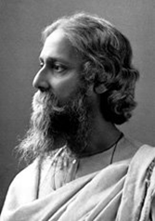
1. Some key dates:
1857 first major Indian rebellion against British East India Co.
1858 rule transfers to British Crown (beginning of British Raj)
1861 Tagore born, Calcutta (now Kolkata), British India
1880s publishes early Bengali works
1910s publishes first works in English
1913 Gitanjali (Song Offerings) published in Tagore’s own English translation, first writer from beyond Europe to win the Nobel Prize for Literature
1921 founds Visva-Bharati, an alternative, anti-colonial university in Bengal
1930 gives The Religion of Man lectures in Oxford
1941 Tagore dies, Calcutta, British India
1947 India gains independence

2. Let it also be said that he has not valued a sheltered life so far above the public good as to hold himself wholly aloof from the dust and heat of the world outside; for there have been times when he has not scorned to step down into the market-place; when, if he thought that a wrong had been done he has not feared to challenge the British raj itself and the authority of its magistrates; and when he has boldly corrected the faults of his own fellow-citizens….Here before you is the myriad-minded poet and writer, the musician famous in his art, the philosopher proved both in word and deed, the fervent upholder of learning and sound doctrine, the ardent defender of public liberties, one who by the sanctity of his life and character has won for himself the praise of all mankind.
From the public orator’s speech on the occasion of Tagore receiving an Honorary Doctorate from Oxford, 1940, trans. from Latin; see Krishna Dutta and Andrew Robinson, Rabindranath Tagore (Bloomsbury, 1995), p. 352-53.

3. ‘Literature’ (1889) from Rabindranath Tagore, Selected Writings on Literature and Language, eds. Sisir Kumar Das and Sukanta Chaudhuri (Oxford, 2001), pp. 49-50.

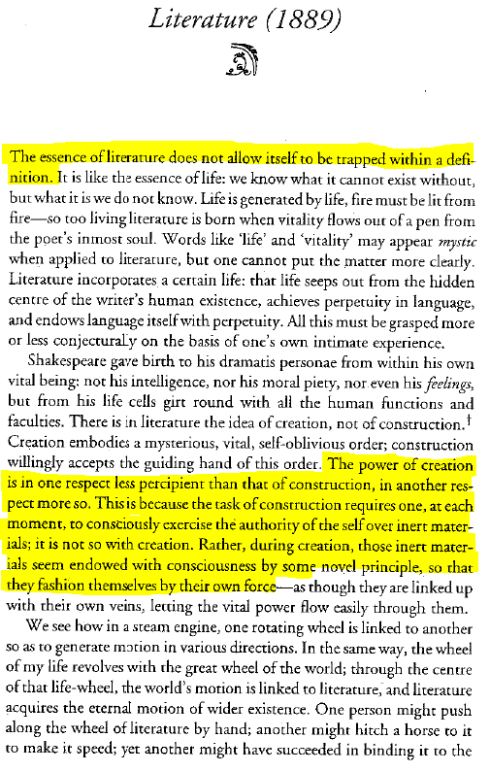
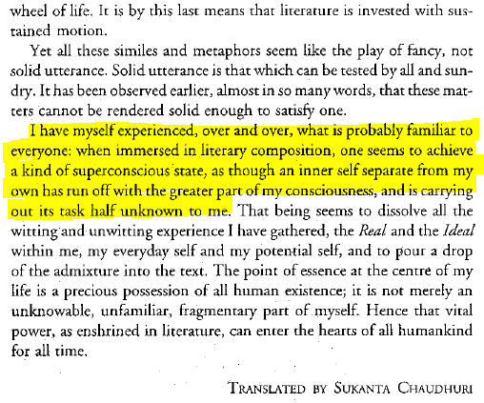
4. Besides the Law of the Universal noted by Aristotle, we have to recognise the existence of another law, the operation of which Aristotle himself did not observe, and indeed had no opportunity of observing, the Law of National Character. By this I mean the social instinct which compels the artist unconsciously to individualise his idea of the Universal in the light of the race tendencies, the methods of education, and the political history and character of the nation to which he belongs.
William John Courthope, Life in Poetry: Law in Taste (Macmillan, 1901), 429-30. Lectures given as Oxford Professor of Poetry, 1895-1900.

5. We ought to contemplate the literature of all civilised people as the progressive development of one entire system, or as a single perfect structure. All prejudiced and narrow ideas will thus unconsciously disappear, many points will first become intelligible in their general connexion, and every feature thus viewed will appear in a new light.
Friedrich Schlegel, ‘On the Language and Wisdom of the Indians’ (1808), trans. from German, The Aesthetic and Miscellaneous Works (London, 1849), p. 526.
6. I am more and more convinced that poetry is the universal possession of mankind, revealing itself everywhere and at all times in hundreds and hundreds of men….I therefore like to look about me in foreign nations, and advise everyone to do the same. National literature is now a rather unmeaning term; the epoch of world literature [Weltliteratur] is at hand, and everyone must strive to hasten its approach.
Goethe to Eckermann, January 1827, trans. from German, 1850, see David Damrosch, ed. World Literature in Theory (Wiley Blackwell, 2014), pp. 19-20.

7. The bourgeoisie has through its exploitation of the world market given a cosmopolitan character to production and consumption in every country….In place of the old local and national seclusion and self-sufficiency, we have intercourse in every direction, universal inter-dependence of nations. And as in material, so also in intellectual production. The intellectual creations of individual nations become common property. National one-sidedness and narrowmindedness become more and more impossible, and from the numerous national and local literatures, there arises a world literature [Weltliteratur].
Karl Marx and Frederick Engels, Manifesto of the Communist Party (1848), trans. from German, 1888.

8. In his 1907 essay “World Literature,” Tagore advocates searching for “the eternal and universal man” in literature. To some extent following Goethe’s notion of Weltliteratur, Tagore turns it to new purposes in colonial India, opposing both a narrow-minded nationalism and the British policy of dividing and conquering India’s many regions and cultures. His “world literature” is a means to move beyond national boundaries to integrate humanity within a universal spirit of culture through the power of imagination.
Headnote to Tagore’s essay, David Damrosch, ed. World Literature in Theory (Wiley Blackwell, 2014), p. 47.

9. Against recent theories of world literature, I have proposed a normative conception that does not simply revive the older vision of world literature as the expression of universal humanity. That vision, which received its canonical articulation by Goethe and which I have described as spiritualist, is not confined to the West. Here is Rabindranath Tagore’s description of how world literature gives us access to humanity’s eternal ideals.
Pheng Cheah, What is a world? (Duke, 2016), p. 310.

10. It is time we pledged that our goal is to view universal humanity in universal literature by freeing ourselves from rustic uncatholicity; that we shall recognise a totality in each particular author’s work, and that in this totality we shall perceive the interrelations among all human efforts at expression.
Tagore, ‘World Literature’ (1907), trans. from Bengali by Swapan Chakravorty, see Rabindranath Tagore, Selected Writings on Literature and Language, eds. Sisir Kumar Das and Sukanta Chaudhuri (Oxford, 2001), p. 150.

11. The time has come to try to free ourselves from narrow parochialism and to aim to see the World-Man [viśva mānab] within the world of literature; to find in the works of particular writers a whole, and in that whole the interrelations among all forms of human expression.
Tagore, ‘World Literature’ (1907), unpublished trans. from Bengali by Rosinka Chaudhuri, 2018/23.

12. I have made the world my home
And my home the world.
I have made “others” my own people,
And my own people “others”.
Chandidas, Bengali medieval (c. 14C) humanist poet, translation from Jeanne Openshaw, Seeking Bāuls of Bengal (Cambridge, 2002), p. vi.

It is nothing but knowing others as our own, and our selves as other. (Chakravorty, 2001 translation, p. 139)
It is when we know the other as our self and our self as other. (Chaudhuri, 2018 translation)

13. This embrace of life, of chance, of play, makes Tagore stand out in the intellectual and moral ethos of late romanticism and modernism—an ethos with which Tagore shares several obsessions (time, memory, the moment, the nature of reality, poetic form), but whose metaphysics he constantly refutes. By metaphysics I mean a system whereby value and meaning have their source elsewhere, somewhere beyond the experienced world.’
Amit Chaudhuri, The Origins of Dislike (2018), p. 70.

14. Rabindranath Tagore, I Won’t Let you Go: Selected Poems, trans. K. Kushari Dyson (Bloodaxe Books, 2010), pp. 150-51. Tagore did not include the poem in the first English Gitanjali—Song Offerings (1913).

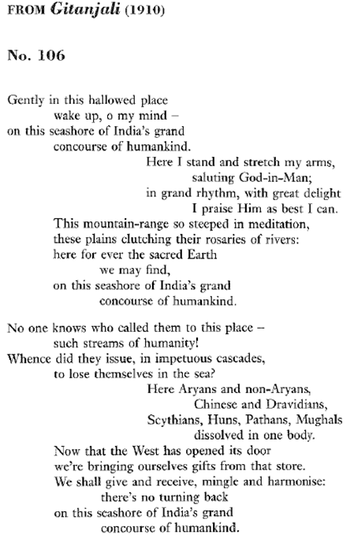

15. Matthew Arnold, Empedocles on Etna (1852), lines 345-54.
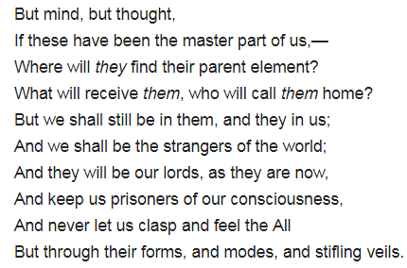

‘The Indians distinguish between meditation and absorption—and knowledge: and between abandoning practice and abandoning the fruits of action and all respect thereto. This last is a supreme step, and dilated on throughout the Poem.’ Arnold to Clough about The Bhagavad Gita, 4 March 1848 (p. 71); compare Gita, 12.12: ‘Knowledge is better than practice, meditation is better than knowledge, renouncing the fruit of action is better than meditation; peace immediately follows such renunciation.’ See also Arnold’s poem Resignation (1849).

Further Reading:
H. F. Lowry, ed. The Letters of Matthew Arnold to Arthur Hugh Clough, ed. H. F. Lowry (London, 1932).
Rosinka Chaudhuri, The Literary Thing: History, Poetry, and the Making of a Modern Literary Culture (Oxford, 2013).
Peter D. McDonald, Artefacts of Writing: Ideas of the State and Communities of Letters from Matthew Arnold to Xu Bing (Oxford, 2017), see also www.artefactsofwriting.com.
Peter D. McDonald, ‘Seeing through the Concept of World Literature’, Journal of World Literature, 4 (2019).
S. Nagarajan, ‘Arnold and the Bhagavad Gita: A Reinterpretation of Empedocles on Etna’, Comparative Literature, 12. 4 (1960), pp. 335-47.
Martha Nussbaum, Political Emotions (Harvard, 2013).
Rabindranath Tagore, The Home and the World (Bengali 1916, English 1919; Penguin Classics, 2005).
Anniyil Tharakan, Matthew Arnold and the Bhagavad Gita: a study in the light of nineteenth century British interest in the East (Carmel, 2006).

